Slide 1

What is NFT ?

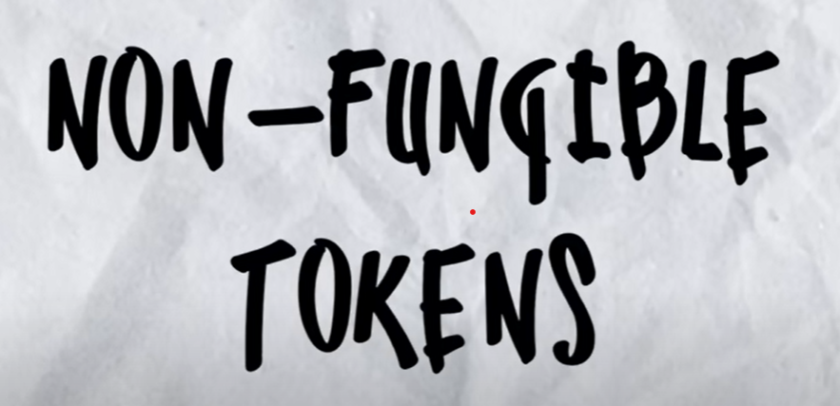

NFTs or Non-Fungible Tokens are digital assets that represent ownership or proof of authenticity of a unique item or asset, such as digital art, music, videos, etc. They are built on blockchain technology, which provides a secure and transparent way to track ownership and transfer of these assets

NFTs can be traded and exchanged for money, cryptocurrencies, or other NFTs—it all depends on the value the market and owners have placed on them

Slide 2

How blockchain is connected to NFTs

The key difference between NFTs and other cryptographic tokens is that NFTs are not fungible – hence the name non-fungible tokens. Fungibility is the property that determines whether or not one item can be interchanged with other items of the same kind with no loss of value.

Just as blockchain brought fungibility to the digital space, and allowed us to exchange value like-for-like in the form of cryptocurrencies, blockchain now brings non-fungibility to the digital space in the form of NFTs.

Slide 3

What is Metaverse ??

Imagine a virtual world where billions of people live, work, shop, learn and interact with each other -- all from the comfort of their couches in the physical world. 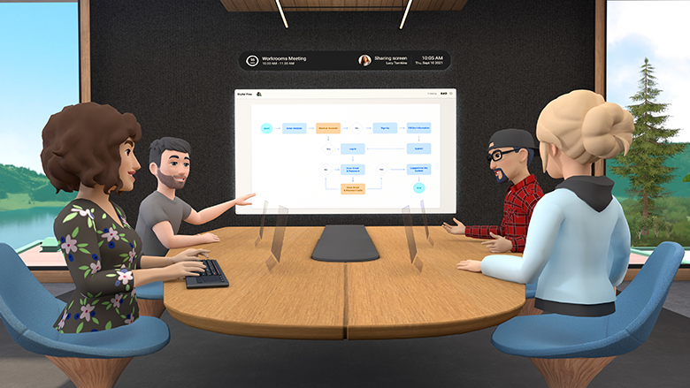

Why is metaverse important ??

When your digital self is more important that your physical self , So metaverse is triggered .

Avatars are essentially virtual identities that allow users to interact with others and navigate the virtual world.

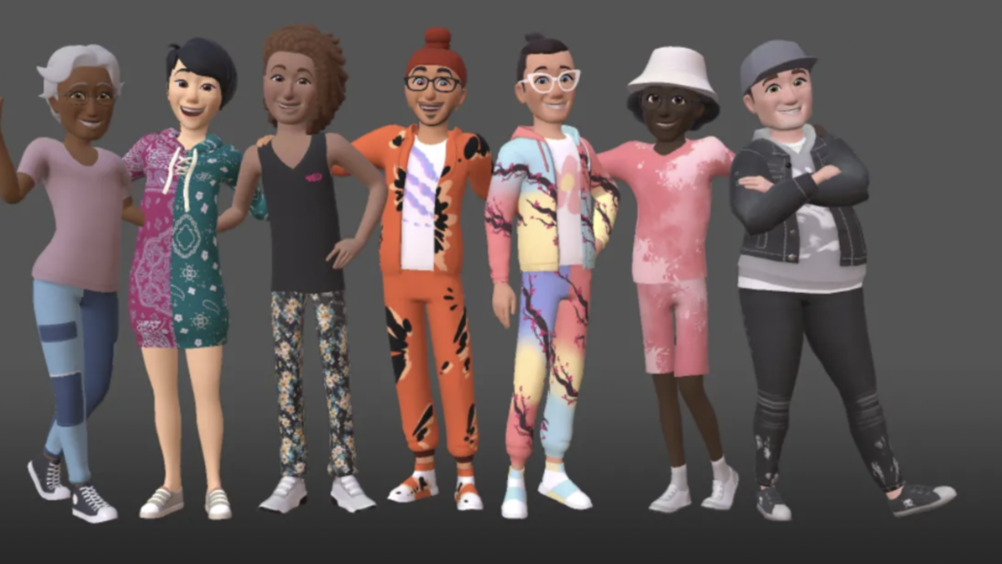

Metaverse Use cases

1. Real estate

It's **real estate that is virtual, where parcels of land are sold**. And, it's less new than you think. People have been working on it and building whole worlds for a very long time." “ It's less new than you think

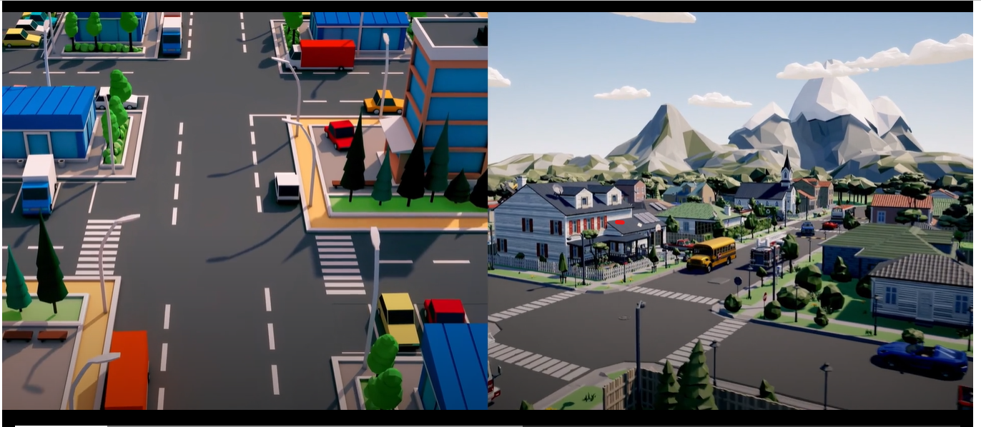

1. Travel



**The metaverse can provide people (who might not be able to travel physically) a way to explore the world**, either as a substitute for an in-person visit or as a way to prepare for an upcoming trip.

1. Music

The metaverse is **a new space in which musicians and the communities that spring up around them can congregate and interact**

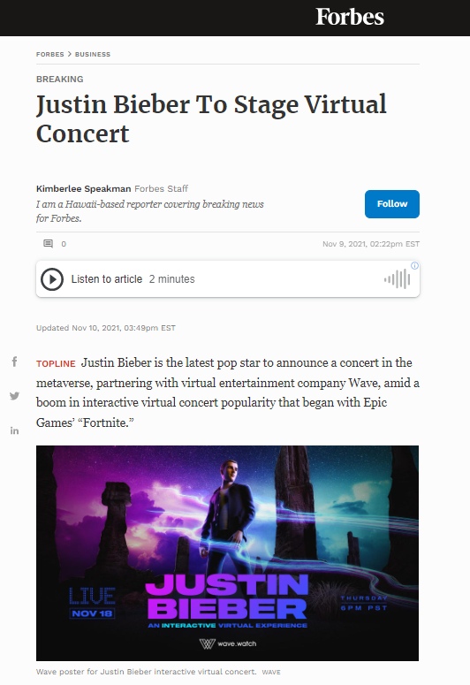

1. **Shopping**

The way we shop and interact with retailers is changing as technology advances. The emergence of the Metaverse, a virtual reality space where people can interact with one another and with virtual objects and environments, is one of the most exciting developments in this realm.

Digital twins, which are digital replicas of physical assets, processes, and systems, can be used in conjunction with the Metaverse to create more realistic and interactive virtual experiences.

These technologies have the potential to transform the[retail industry](https://www.treedis.com/solutions-by-industry/retail-and-showrooms) by enabling retailers to create immersive and personalized shopping experiences and optimize operations and supply chains, while promoting their brand and imposing themselves as early adopters.

‍

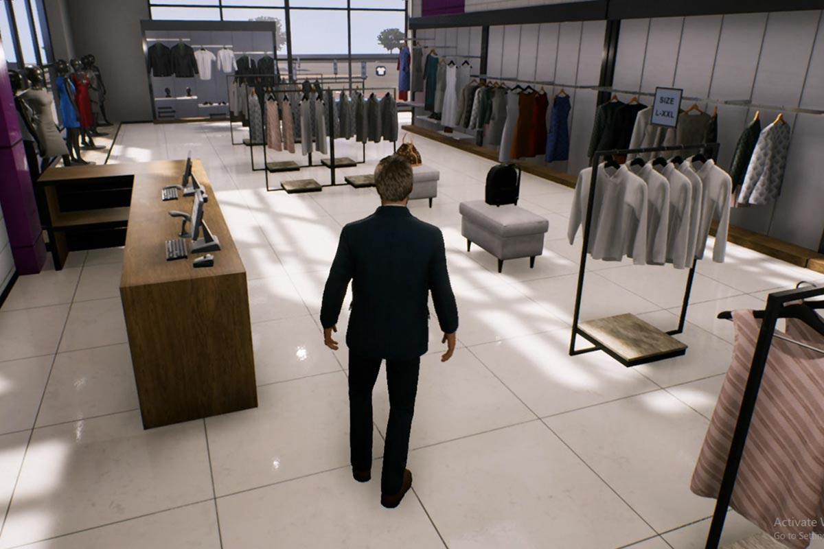

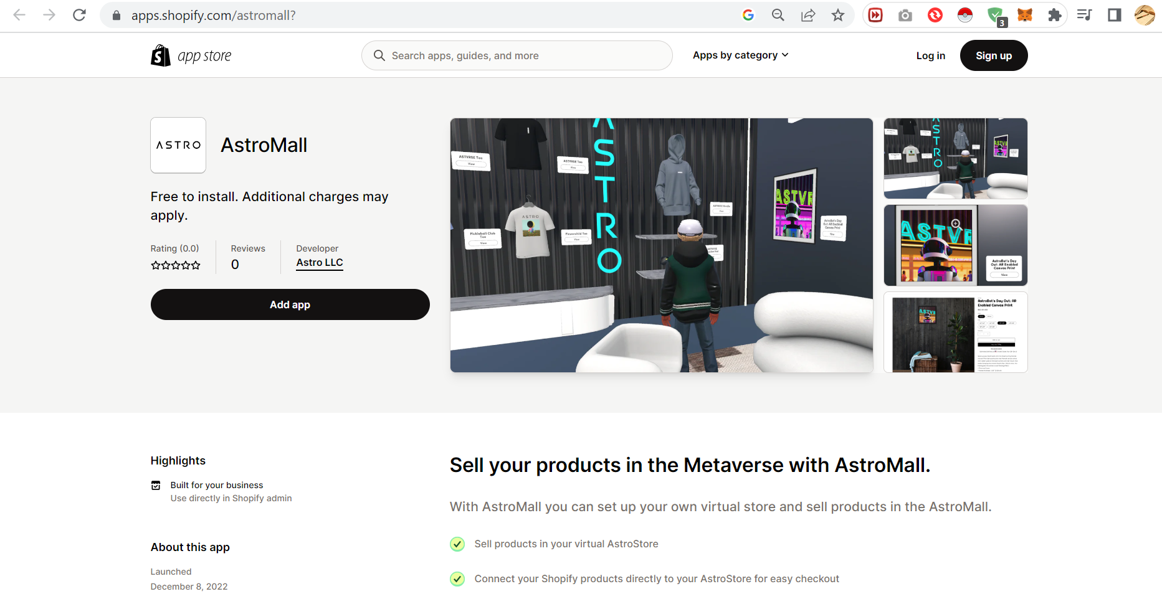

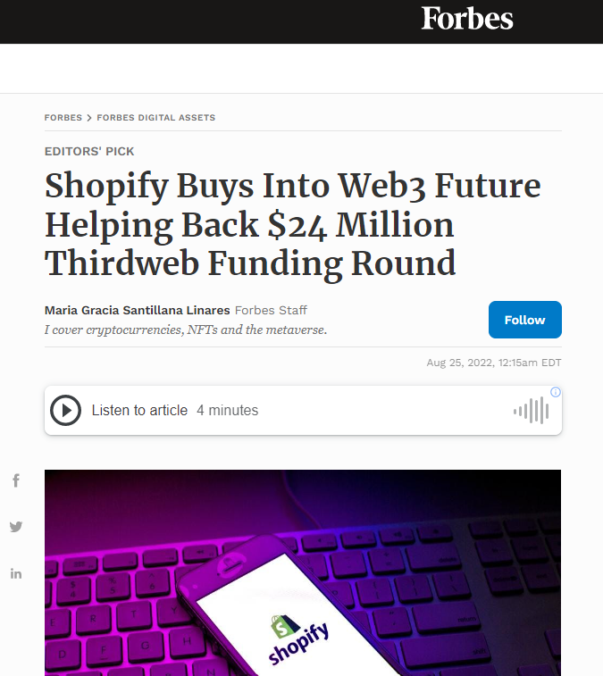

Are Their multiple metaverse ??

The metaverse concept suggests that there is one common and shared virtual ground that everybody shares. But, as we have seen, there can be various metaverses that are separate from each other.

Therefore each metaverse has a specific function in the collective of metaverses. In the same way, as each social media platform provides specific services to its users, metaverses offer distinct virtual possibilities. Likewise to earlier examples, one metaverse could concentrate on gaming while others on meetups or concerts.

Popular examples of the metaverse include Cryptovoxels, Decentraland, Roblox, Somnium Space, and The Sandbox. Metaverses like CryptoVoxels, Decentraland, and Somnium space are advertised more so as VR platforms, whereas Roblox and The Sandbox are better known as online gaming platforms.

Likewise, [big companies](https://academy.binance.com/en/articles/global-companies-building-up-the-metaverse) like Microsoft, Google, and Tencent are building metaverse and are entering the space by developing new technologies.

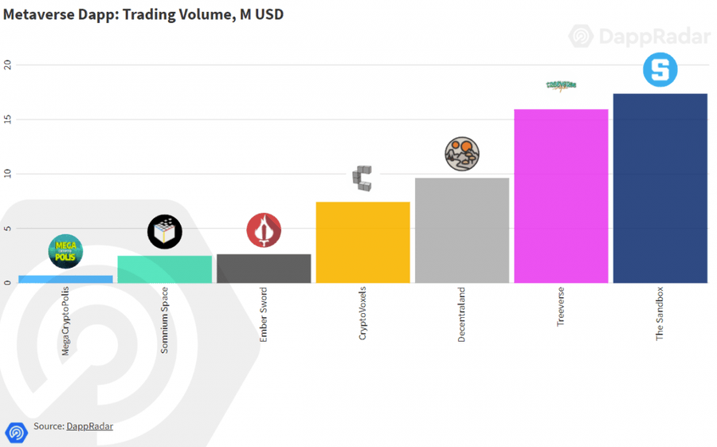

Metaverse has also a map

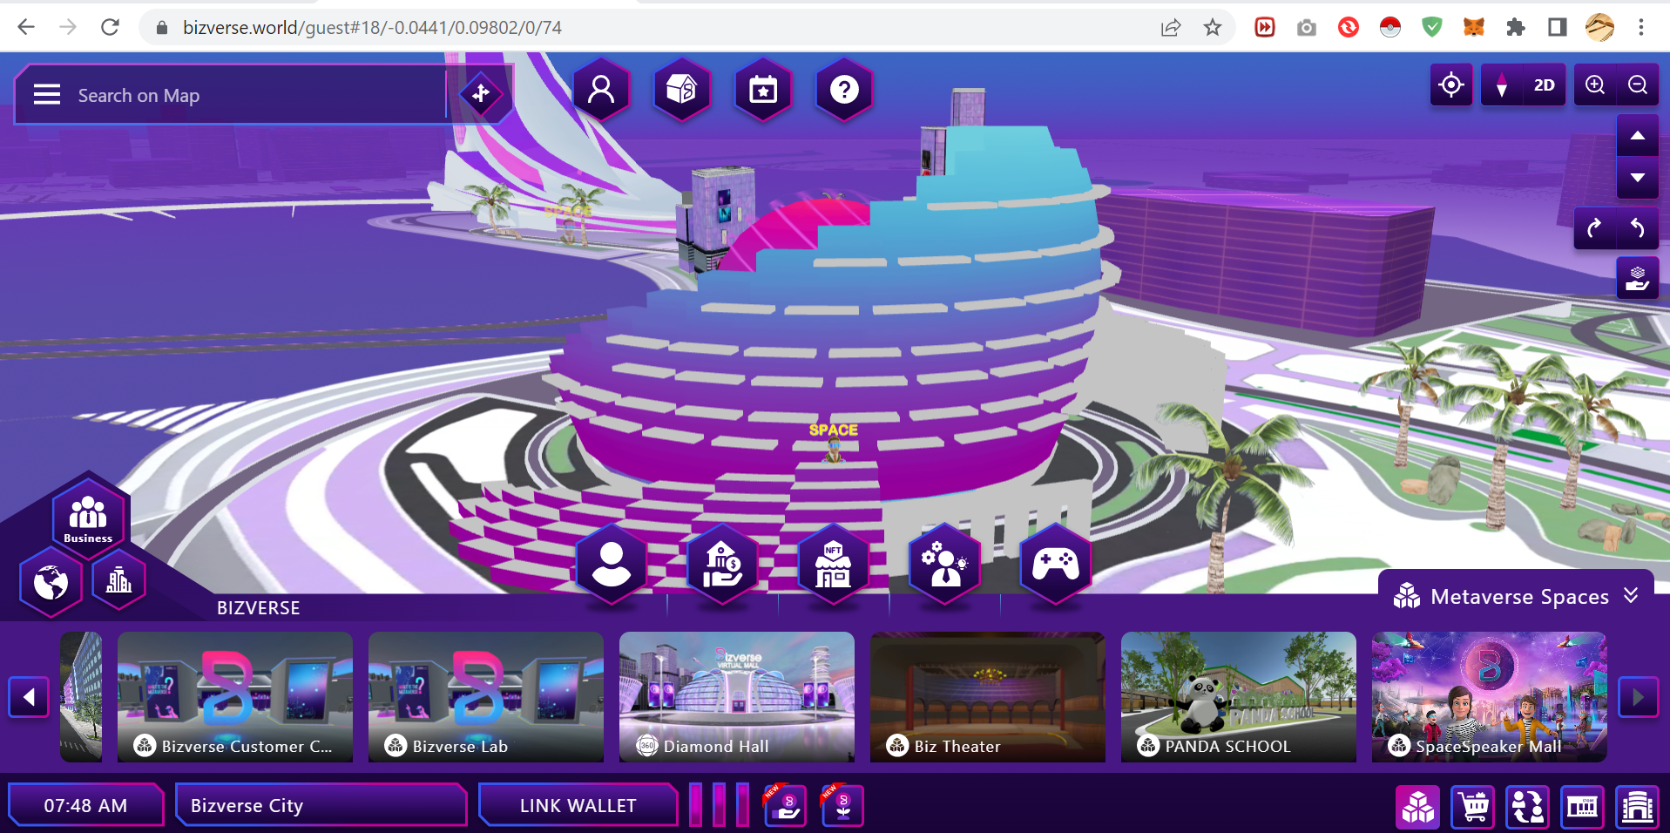

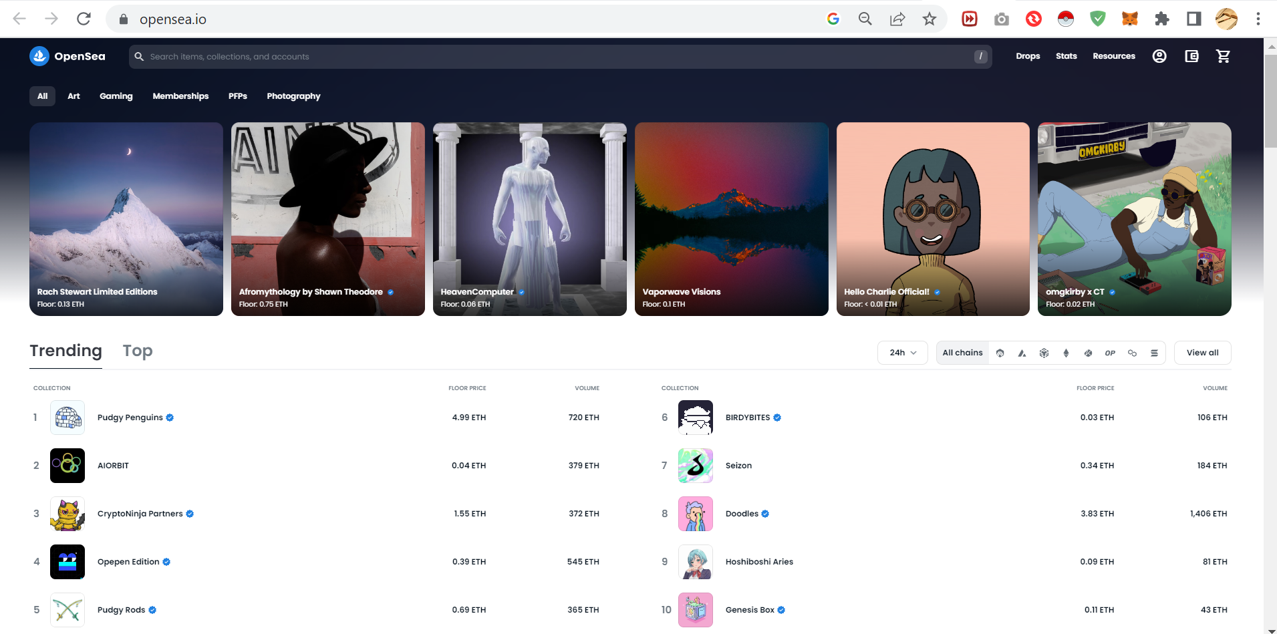

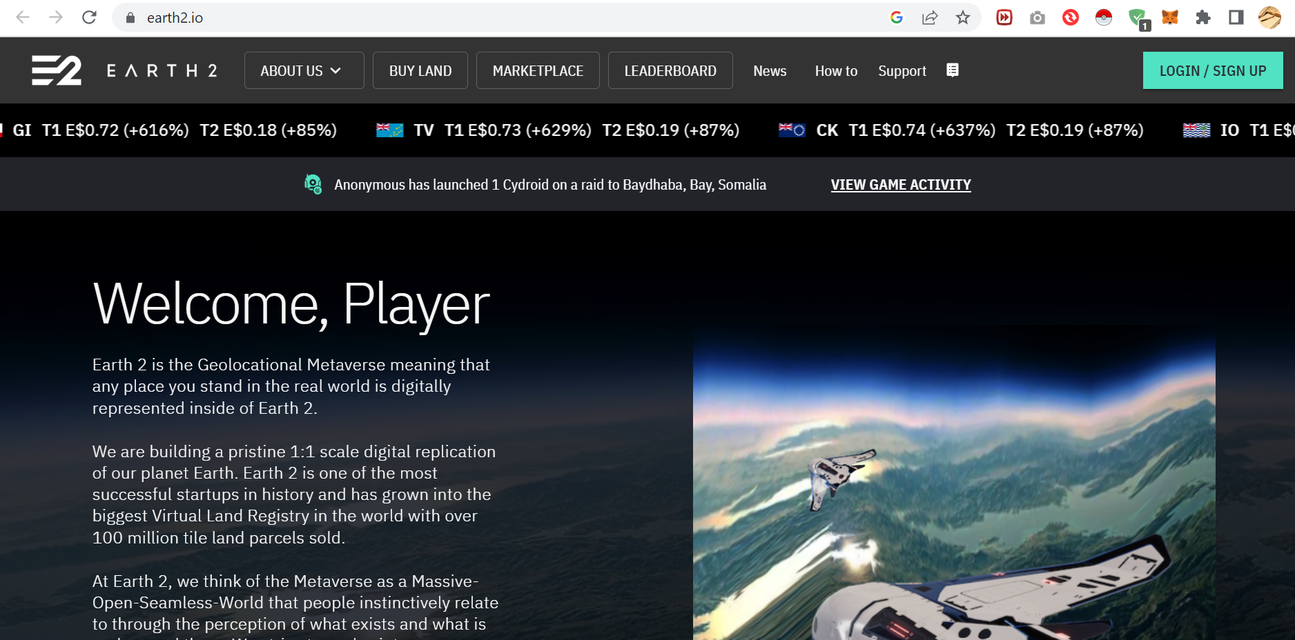

Can trade and convert it to real money.

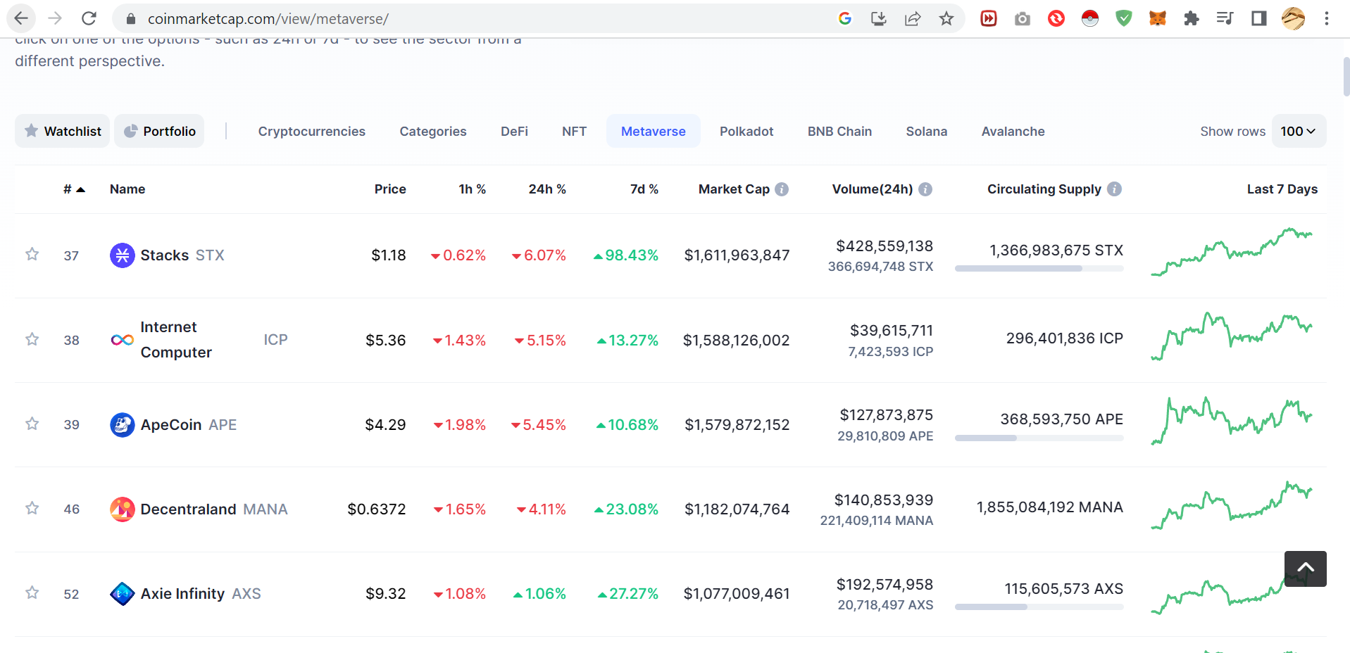

Where are we as a bank ?

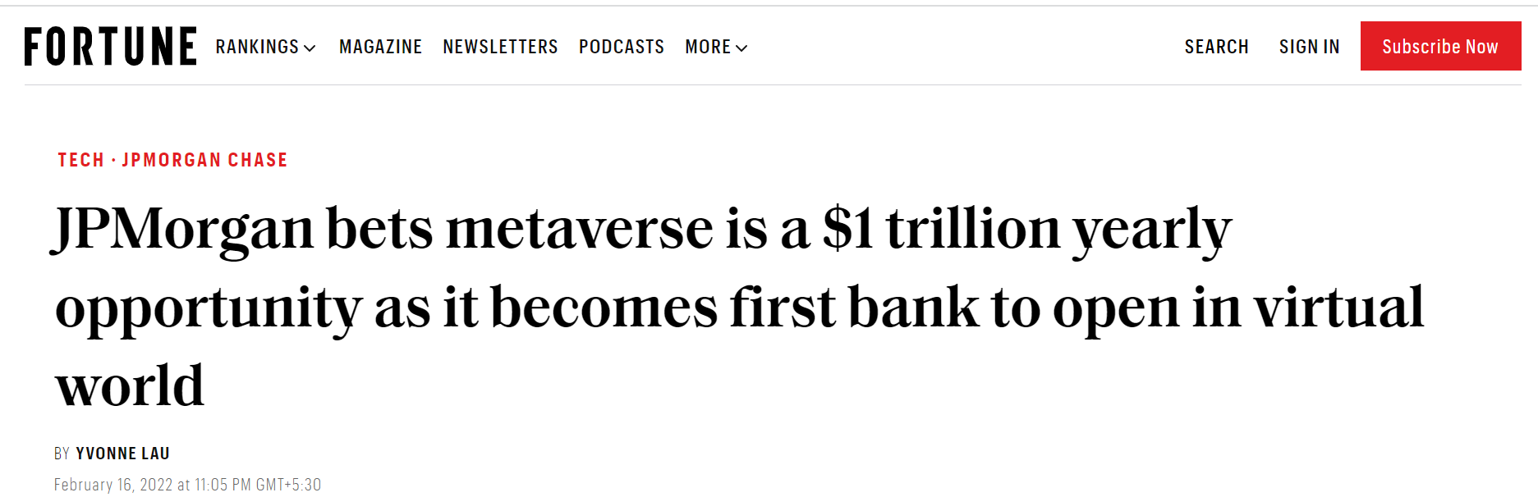

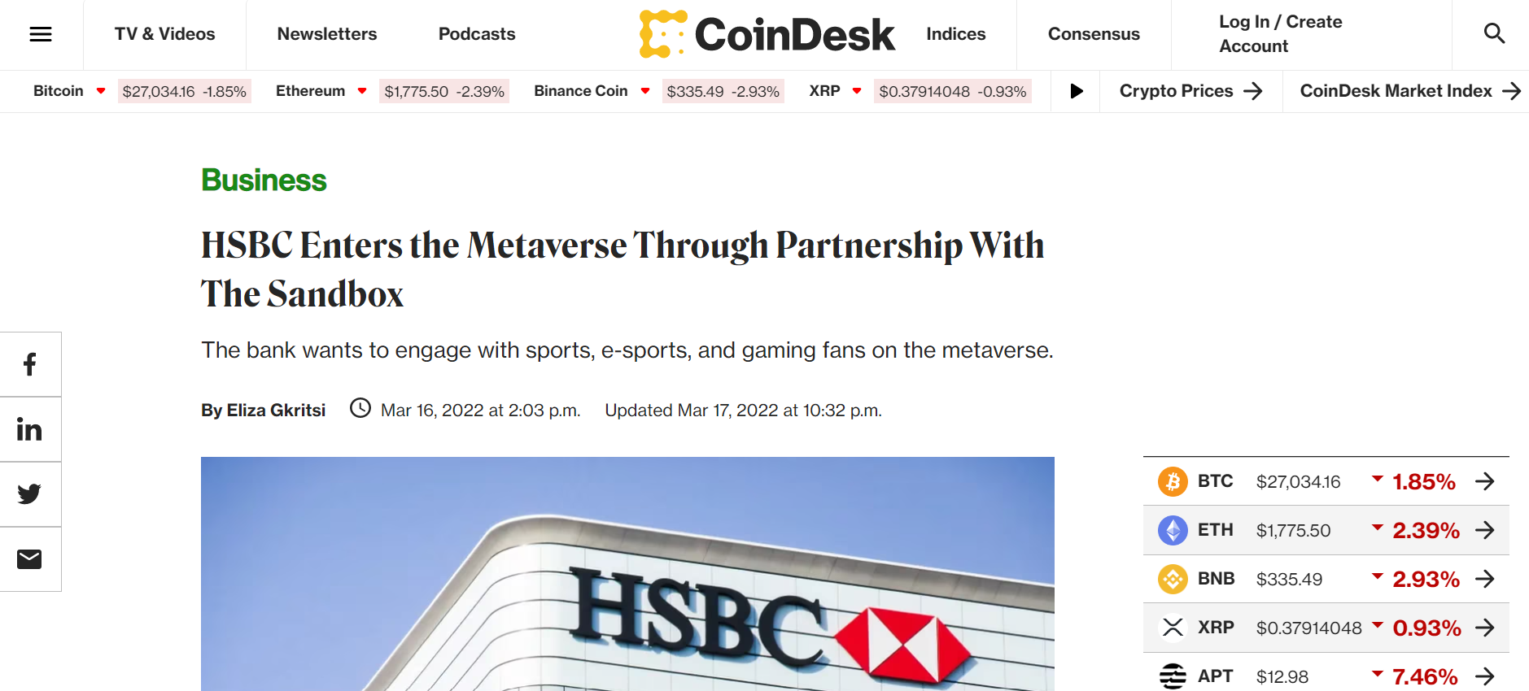

**25 April 2022, Hong Kong – Standard Chartered Bank (Hong Kong) Limited** (“SCBHK”) today announced a new partnership with The Sandbox, a leading decentralised gaming virtual world, to create innovative experiences for our clients and the community.

SCBHK is the first bank to acquire virtual land at The Sandbox metaverse’s Mega City district, a culture hub based on or inspired by Hong Kong talents.

Led by SC Ventures, Standard Chartered Group’s innovation, fintech investment and ventures arm, SCBHK will actively engage its clients, partners, staff, and the tech community, to explore co-creation opportunities in this new and exciting space, with the goal of experimenting and building new experiences for clients, as well as bringing the local sports and art communities into the metaverse.

**Mary Huen, Chief Executive of Standard Chartered, Hong Kong** said: “The metaverse is a vision for the next phase in the internet’s evolution, bringing new possibilities and unique experiences through the use of immersive technologies. Our involvement in the metaverse allows us to reimagine our relationship with existing and potential clients on this new platform and our approach to enhance client journeys. Having acquired virtual land in Mega City, a natural choice for the Bank given its distinctive Hong Kong theme, perfectly fits with our promise of strengthening our continued presence in Hong Kong, whether physical or virtual.”

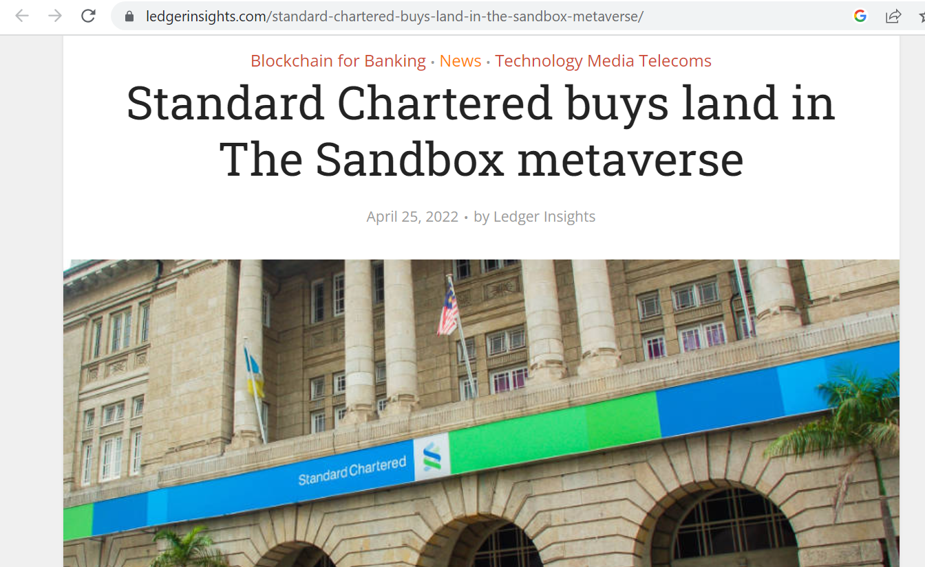

Risk Involved

1. Financial risks

Too early to conclude

Difficult to calculate intrinsic value

High risk High return

1. Emotional connect